Reverse Garbage 2017
Price list and order form
Kit/item | Contents | Unit price | Order Quantity | Total Cost
Madala Kit  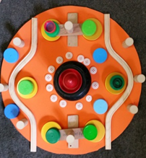 | Barrel full to the brim of bottle tops, buttons, zips, records and myriad of items to create 1000’s of designs. EVA skins included to cut into circles to use as a circular base on which to create. Use the banner to work on and the barrel to store in between play. | $33.00  Inc GST
Stamp Kit  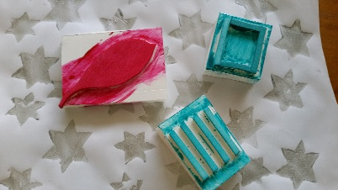 | Create your own stamps to decorate paper or cards for any occasion. Kit includes double sided foam, corks, foam core and interesting textures to make the stamp. You need to provide craft glue and knife to cut foam core. Great fun for all. | $12.50  Inc GST
Twirly Whirly  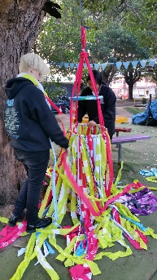 | Create your own twirly whirly in your centre, beautiful to watch in the breeze, hide and play with. Comes with fully photographed instructions and everything you need to make one twirly whirly. | $25
Scare Crow Kit  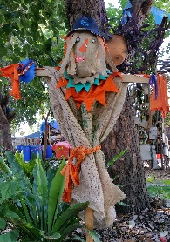 | Perfect for the school, community or home garden, Reg the reuse Scare Crow will not only keep away those pesky pests he’ll add some interest to your garden. | $25  Inc GST
Kit/Item | Contents | Unit price | Order Quantity | Total Cost
Fill a Barrel | Reverse Garbage in a barrel! Filled with unique items from our fill a bag area. So much creativity in one barrel. Every one different. | $20
Desk paper Pads | Great for drawing and origami | $1.00
Cones | For craft and constructions! | 0.50c
Zippers | Great for sensory boards | 0.50c
Tea Tins | Great for storage or play | $2.00
Shoe lasts | Loose parts and fun | $3.00
Rolls of elastic | So many uses per roll. | $15.00
Banner see photo below | Reuse City of Sydney banners | $5 each
Banners  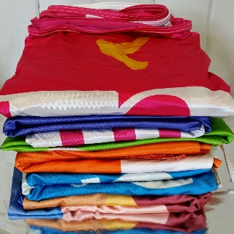 | Great source of durable fabric for free-play, craft and costumes | 3 for $10

We are able to post Australia wide either using Sendle or Austalia Post, whatever the size of your order. Once we have collated your order we will be in touch with a quote for delivery. Thank for shopping Re-Use at Reverse Garbage. Please fill out form with details.
Name of Centre ____________________________________________________________
Phn Number_______________________________________________________________
Contact name ______________________________________________________________
Delivery Address ____________________________________________________________
____________________________________________________________
Credit Card Details ____________________________________EXP _____ / ______ CCV _______

Would you like to join our Fresh Garbage Newsletter email list ___Y ____N
Reverse Garbage is open 7 days Mon-Sat 9am-4pm and Sun 9am-4pm. We are always posting unusual and unique items on our Facebook and Instagram pages, search Reverse Garbage.
www.reversegarbage.org.au info@reversegarbage.org.au 02 9569 3132
8/142 Addison Rd, Marrickville, NSW, 2204 Tax Receipt/Invoice ABN 70561909900

